TITLE: Wearable Smart Backpack with Integrated Automatic Umbrella
ABSTRACT

The design patent titled “Wearable Smart Backpack with Integrated Automatic Umbrella” features an innovative and functional backpack equipped with an integrated umbrella mechanism, designed to offer users protection from weather elements while maintaining convenience and style. The backpack includes a built-in compartment that houses a retractable umbrella, which automatically deploys with the push of a button, providing immediate coverage during rain or adverse weather. The design emphasizes ergonomic comfort, with adjustable straps and breathable materials for ease of use during extended wear. The streamlined, modern aesthetic ensures the wearable smart backpack remains both practical and fashionable. The backpack also incorporates a power source to operate the automatic umbrella mechanism, as well as potential integration for smart device charging. This unique combination of functionality, weather protection, and wearable technology makes the smart backpack an ideal solution for active individuals seeking versatility and protection on the go.

Ms. V.Dishitha Dr. Rajesh Arunachalam

THE FIELD OF INVENTION
The field of invention pertains to wearable technology and personal accessories, specifically focusing on backpacks integrated with automatic umbrella systems. This invention combines functionality and convenience, offering users an innovative solution for weather protection while maintaining ergonomic design and style.

BACKGROUND OF THE INVENTION
The present invention relates to wearable accessories and, more specifically, to a smart backpack that integrates an automatic umbrella system. Traditionally, backpacks are designed to carry personal belongings and provide comfort during daily activities. However, they do not offer effective solutions for protection from weather elements such as rain or snow, which can make commuting or outdoor activities inconvenient. Individuals often need to carry separate umbrellas or face exposure to the elements, leading to discomfort or inconvenience.
Recent advancements in wearable technology have led to the development of multifunctional accessories that combine traditional designs with innovative features. Despite this progress, there remains a gap in the market for a backpack that combines practicality with automatic weather protection in a single device. While some backpacks have been designed with integrated rain covers or other protective elements, these solutions typically require manual intervention or are cumbersome to use.
The "Wearable Smart Backpack with Integrated Automatic Umbrella" solves this issue by combining a smart, ergonomic backpack with an automatic umbrella system that deploys at the touch of a button. The umbrella is neatly housed within the backpack, ensuring the design remains sleek and functional while offering immediate weather protection. By incorporating this technology, the backpack becomes an all-in-one solution for individuals seeking to stay dry and comfortable while carrying their essentials. This integration represents a significant improvement over traditional umbrellas and backpacks, providing convenience, ease of use, and protection from the elements without compromising on style or functionality.

Ms. V.Dishitha Dr. Rajesh Arunachalam
SUMMARY OF THE INVENTION
The invention is a wearable smart backpack featuring an integrated automatic umbrella system. The umbrella, housed within the backpack, can be deployed at the push of a button, providing immediate weather protection. This innovative design combines convenience, functionality, and style, offering users protection from the elements while carrying their belongings.

Ms.V.Dishitha Dr. Rajesh Arunachalam

SPECIFICATION
- The backpack features a built-in, retractable automatic umbrella that deploys with the push of a button for immediate weather protection.
- An ergonomic design with adjustable straps ensures comfort during extended wear, providing a secure and breathable fit.
- The backpack is made from durable, lightweight materials to withstand daily use while maintaining a sleek appearance.
- The umbrella mechanism is seamlessly integrated into the backpack, allowing for easy storage when not in use, preserving the bag’s aesthetic.
- The system includes a power source to operate the automatic umbrella, offering convenience for users on the go.
- The design combines functionality with style, providing users with both practicality and modern aesthetics for everyday use.

Ms.V.Dishitha Dr. Rajesh Arunachalam

DESCRIPTION
The "Wearable Smart Backpack with Integrated Automatic Umbrella" is an innovative accessory that combines the functionality of a backpack with the convenience of an automatic umbrella system. The backpack features a retractable umbrella housed within its structure, which can be deployed with a simple push of a button, offering users immediate weather protection without the need for carrying a separate umbrella. Designed for comfort, the backpack includes adjustable straps and breathable materials, ensuring a snug fit during extended use. The umbrella mechanism is powered by an integrated power source, making it easy to operate when needed. The sleek and modern design of the backpack maintains a balance between style and practicality, allowing users to carry their essentials while staying dry in adverse weather conditions. The system is lightweight, easy to use, and simple to install, making it an ideal solution for active individuals seeking both convenience and protection from the elements.

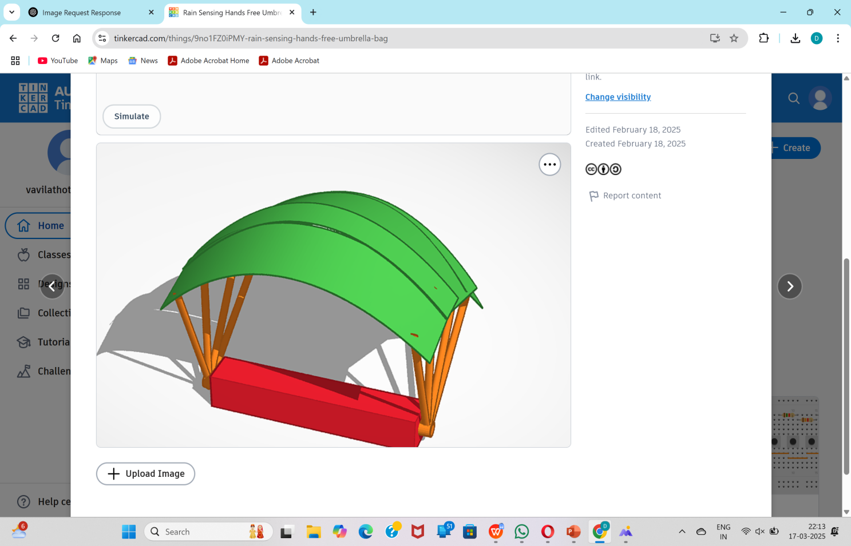

Figure 2: 3D Sketch of Wearable Smart Backpack with Integrated Automatic Umbrella

Figure 1: Schematic diagram of Wearable Smart Backpack with Integrated Automatic Umbrella

Ms.V.Dishitha Dr.Rajesh Arunachalam
WE CLAIM
- Claim: A wearable smart backpack comprising an integrated retractable automatic umbrella, the umbrella being housed within a compartment of the backpack and capable of being deployed with a single button press.
- Claim: The wearable smart backpack of claim 1, wherein the backpack includes adjustable straps and breathable materials for ergonomic comfort during extended wear.
- Claim: The wearable smart backpack of claim 1, further including a power source for operating the automatic umbrella, ensuring seamless deployment when needed.
- Claim: The wearable smart backpack of claim 1, wherein the retractable umbrella is designed to retract into a compact, streamlined compartment to maintain the aesthetic appearance of the backpack when not in use.
- Claim: The wearable smart backpack of claim 1, wherein the umbrella is activated by a push button integrated into the backpack, providing ease of use.
- Claim: The wearable smart backpack of claim 1, wherein the umbrella provides protection from adverse weather conditions, including rain and snow.
- Claim: The wearable smart backpack of claim 1, wherein the backpack’s materials are durable, lightweight, and weather-resistant, ensuring long-lasting use and protection in various environmental conditions.

Ms.V.Dishitha Dr. Rajesh Arunachalam

